Declaration

ABSTRACT

In the modern cybersecurity landscape, detecting and analyzing unauthorized access attempts is a crucial aspect of network defense. However, most educational honeypots only generate raw logs that are difficult to interpret, especially for beginners. To address this challenge, this project — IntruViz : Honeypot with Visualization Dashboard for Intrusion Analysis — proposes the development of a lightweight, fully custom honeypot built entirely from scratch. The system aims to simulate vulnerable network services within a controlled local area network (LAN) to attract and record intrusion attempts while ensuring a safe and isolated environment for experimentation.
Unlike traditional honeypot implementations that rely on pre-built tools such as Pentbox or Cowrie, IntruViz focuses on simplicity, educational value, and real-time data presentation. The project integrates a Python-based backend to capture and log connection details such as attacker IP addresses, accessed ports, and timestamps. These logs are then processed through a Flask server and visually represented using Chart.js in a dynamic dashboard, allowing users to easily interpret attack patterns and behaviours. Additionally, the use of GeoIP lookups provides geographical insights into intrusion origins, enhancing situational awareness.
This project emphasizes a step-by-step learning approach — starting from fundamental networking concepts, Linux command-line operations, and Python scripting, to gradually building a functional cybersecurity tool. Designed for educational and research purposes, IntruViz bridges the gap between technical logging and practical visualization, offering a clear, interactive way to understand intrusion behaviour. Through its modular and beginner-friendly design, it lays the foundation for future enhancements such as alert mechanisms and machine learning–based intrusion detection.

Index
DECLARATION 1
ABSTRACT 2
CHAPTER 1: Introduction 4
Project Definition 4
Objectives and Scope 4
CHAPTER 2: Project Overview 5
CHAPTER 3: Literature Review 6
Existing Solutions in the Domain 6
Comparative Analysis of Existing Platforms 6
How This Project Differs and Builds Upon Existing Work 6
CHAPTER 4: System Analysis 7
Functional Requirements 7
Non-Functional Requirements 8
CHAPTER 5: Technology Stack 9
CHAPTER 6: System Design 10
CHAPTER 7: Results 11
CHAPTER 8: Challenges faced 14
CHAPTER 9: Future Work And Conclusion 16
Future Work 16
Conclusion 17
References 18

Introduction

1. Project Definition
Existing honeypot tools such as Pentbox, Cowrie, and Honeyd are effective but come with certain limitations:
- They are complex for beginners to set up and understand.
- Most of them present data in raw text form, which makes analysis difficult.
- They often lack real-time visualization and interactive dashboards.
As a result, there is a lack of simple, educational honeypot systems that allow students and new learners to see how network attacks occur and interpret them meaningfully.
The problem this project addresses is the difficulty of analyzing intrusion data in a visually understandable format, especially for users new to cybersecurity.
2. Objectives and Scope of the Project

Objectives
- To develop a lightweight honeypot capable of simulating vulnerable network services and capturing intrusion attempts.
- To log network activity including attacker IP address, port number, timestamp, and connection details.
- To build a real-time visualization dashboard that represents this data in charts and graphs for easier understanding.

Scope
- The project will operate within a controlled local network (LAN) environment, ensuring complete safety and isolation from live internet exposure.
- It is intended for educational and research purposes rather than enterprise-level deployment.
- The focus is primarily on detection and visualization, not on prevention or active defense mechanisms.

Project Overview
The project “IntruViz: Honeypot with Visualization Dashboard for Intrusion Analysis” aims to design and implement a custom honeypot system that can detect, log, and visually represent unauthorized access attempts in a controlled local network environment. Built entirely from scratch using Python and Flask, the system simulates vulnerable services such as SSH and HTTP to attract attackers and record their activities. Each intrusion attempt is logged with vital information, including the attacker’s IP address, port accessed, timestamp, and geographic location. The logged data is then stored in structured formats like SQLite and JSON for analysis. A Flask-based backend processes this data and displays it on an interactive web dashboard, built with HTML, CSS, JavaScript, and Chart.js, offering real-time insights into attack patterns, port usage, and frequency. The integration of GeoIP APIs enhances this dashboard by mapping the origin of attacks geographically, providing an intuitive understanding of intrusion sources. Designed to operate within a secure LAN, IntruViz focuses on educational value, simplicity, and modularity, making it an ideal tool for cybersecurity learners to observe attacker behavior safely and effectively.
Core Features:
- Custom-Built Honeypot:
Simulates vulnerable network services like SSH or HTTP using Python to attract potential attackers.
- Real-Time Intrusion Logging:
Captures detailed data such as IP address, port number, timestamp, and connection details for every unauthorized attempt.
- Visualization Dashboard:
Displays attack trends and statistics using interactive charts and graphs powered by Chart.js and JavaScript.
- GeoIP Integration:
Maps the attacker’s approximate geographical location to provide better situational awareness.
- Modular System Architecture:
Organized into distinct modules — Honeypot, Logging, Backend Processing, and Visualization — ensuring scalability and easy maintenance.
- Secure and Isolated Environment:
Runs safely within a local LAN, ensuring no exposure to live internet threats.
- Lightweight and Beginner-Friendly Design:
Uses simple technologies like Flask, SQLite, and JSON to remain easy to deploy and understand for students and educators.
- Testing and Simulation Support:
Compatible with tools like Nmap and Netcat for generating controlled test attacks and validating honeypot behavior.
Literature Review
1. Existing Solutions in the Domain
Honeypots have long been recognized as effective tools in cybersecurity for detecting, studying, and analyzing intrusion attempts. They serve as deceptive systems that attract attackers, record their behavior, and help researchers understand evolving attack patterns.
Existing studies emphasize that honeypots are primarily categorized into low, medium, and high-interaction types, each providing varying levels of engagement with attackers (Spitzner, 2003). Low-interaction honeypots, such as Honeyd, emulate limited network services and are safer for educational environments, while high-interaction honeypots, like Dionaea or Cowrie, offer real systems to attackers but require more resources and security precautions.
2. Comparative Analysis of Existing Platforms
Tool / Platform | Type | Advantages | Limitations
Pentbox | Low-interaction | Simple to deploy; good for demos | No real-time data visualization; limited flexibility
Honeyd | Low-interaction | Simulates multiple network services | Complex setup; steep learning curve
Cowrie | Medium-interaction | Logs SSH & Telnet sessions | Heavy configuration; raw text logs only
Dionaea | Medium-interaction | Captures malware samples | Resource intensive; not beginner-friendly

3. How This Project Differs and Builds Upon Existing Work

Key differentiators include:

Built from scratch using Python, avoiding reliance on pre-built honeypot frameworks.

Integration of real-time log visualization, converting plain log data into intuitive charts and graphs using Flask and Chart.js.

GeoIP-based attacker mapping to provide geographical insights into network activity.

Designed to operate safely in a controlled LAN environment, making it ideal for academic and training use.

System Analysis

1. Functional Requirements
Functional requirements define the specific operations and behaviors that the system must perform.
For the IntruViz project, these include:
- Honeypot Simulation- The system must simulate vulnerable network services (e.g., open ports) to attract unauthorized access attempts within a local network.
- Connection Logging- Every incoming connection or intrusion attempt must be recorded with details such as:
  - Attacker IP address
  - Target port number
  - Timestamp of the attempt
- Data Storage and Management- Logged information should be stored in a structured format (e.g., text file, CSV, or database) for further analysis.
- Real-Time Visualization- A Flask-based dashboard must fetch and display logs dynamically using Chart.js to visualize:
  - Frequency of attacks
  - Ports accessed
  - Time-based attack trends
- GeoIP Integration (Optional but planned)- The system should perform an IP lookup to estimate the attacker’s geographical location and display it on the dashboard.
- Testing and Simulation- The system should support internal testing using network tools like Nmap and netcat to simulate attack traffic.
- User Interface- A simple, web-based interface should allow the user to view intrusion trends, logs, and graphical insights.

2. Non-Functional Requirements
Non-functional requirements describe the quality attributes, design constraints, and operational conditions of the system.
- Usability- The system should have a simple and intuitive interface suitable for beginners in cybersecurity.
- Scalability- The architecture should allow adding more features in the future (e.g., alert systems, machine learning–based detection).
- Performance- The honeypot and visualization should run efficiently on a standard personal computer with minimal resource usage.
- Reliability- The system must capture all attempted connections accurately and ensure no data loss in logging.
- Security- The honeypot should operate within a controlled LAN environment to prevent exposure to live internet threats.
- Maintainability- The source code should be modular, with clear documentation to allow easy debugging and updates.
- Portability- The project should run smoothly across major operating systems (preferably Linux-based setups).
- Educational Simplicity- The focus should remain on clarity and understanding, making the system usable as a learning tool for students new to cybersecurity.

Technology Stack
1. Languages Used:
- Python: Primary language for entire project
Reason: Extensive security libraries and frameworks, Strong networking and web development capabilities, Excellent database integration.
- JavaScript (ES6+): Frontend interactivity and real-time dashboard
Reason: Native browser support for real-time features, Excellent WebSocket and API integration
- HTML5 & CSS3: User interface for operator dashboard
Reason: Standard web technologies for universal browser support and responsive design capabilities.
- SQL: Database queries and data analysis
Reason: Standard for relational data operations and powerful aggregation and filtering capabilities.

2. Frameworks & Libraries:
- Flask: Core web framework for honeypot and dashboard
Reason: Lightweight and flexible for security applications and easy to customize for deception techniques.
- Flask-SocketIO: Real-time WebSocket communication
Reason: Seamless real-time event streaming and browser compatibility across all platforms.
- Chart.js: Data visualization for attack analytics
Reason: Beautiful, responsive charts along with real-time data updates.
- Leaflet: Interactive mapping for geographic attack visualization
Reason: Open-source with no API keys required and Excellent marker clustering for attack origins.

3. Tools:
- JSON/JSONL: Data serialization and log storage
Reason: Human-readable attack logs and easy integration with analysis tools.
- Git: Version control and collaboration
Reason: Industry standard for code management.
- Virtual Environment (venv): Dependency isolation
Reason: Prevents conflicts with system packages.
This technology stack provides a perfect balance of simplicity for education, power for research, and standards for real-world application.

System Design
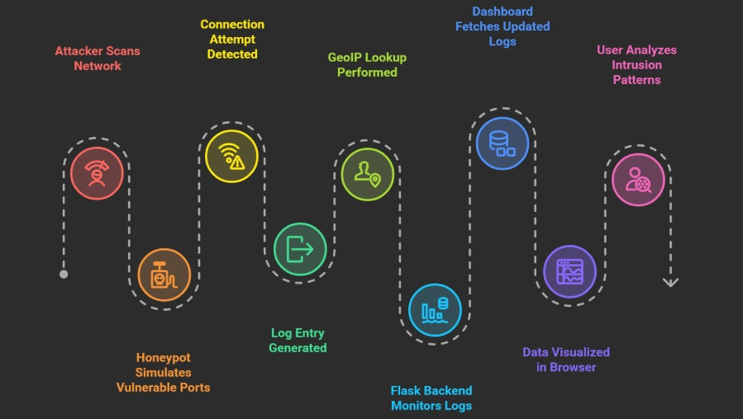
Workflow Diagram
The workflow of the Honeypot system begins with simulating vulnerable network services such as SSH or HTTP using Python scripts to attract unauthorized access attempts. When an attacker interacts with these decoy services, the honeypot captures and logs critical details such as the attacker’s IP address, accessed port, timestamp, and geographic location. These logs are stored in a JSON file or SQLite database for structured record-keeping. The Flask-based backend processes this data and sends it to a visualization dashboard in real-time. The frontend, developed with HTML, CSS, JavaScript, and Chart.js, displays attack patterns through graphical charts and maps, allowing users to analyze intrusion trends easily. This setup helps in understanding attacker behavior while ensuring the environment remains isolated and secure.

Modules / Components Overview
Honeypot Module: Simulates open network services and records incoming connections from potential attackers. It acts as the main data collection unit.
Log Management Module: Handles data storage — writes logs to files or streams them to Flask for real-time analysis.
Backend Processing Module: Reads stored logs, parses them, and serves structured data to the frontend using APIs
Visualization Module: Displays real-time graphs such as attack frequency, port usage, and time-based activity charts.

Results

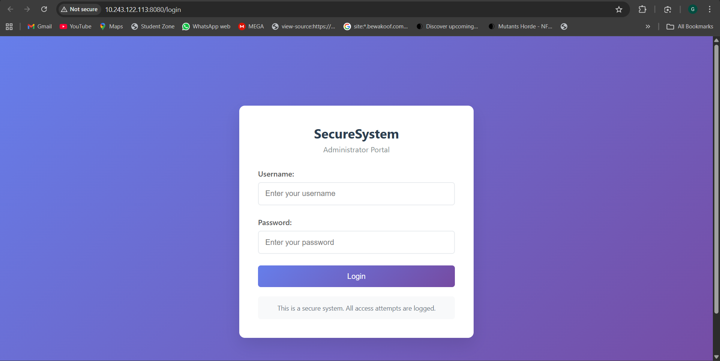

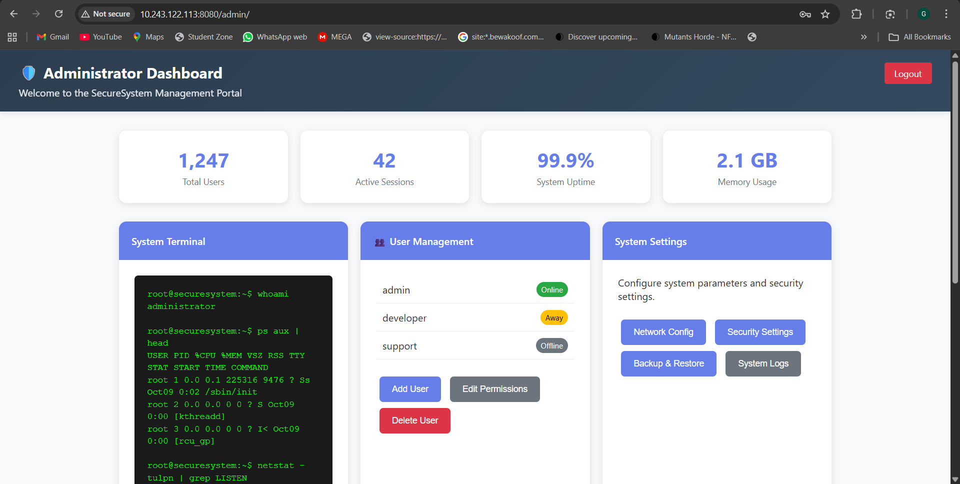
Login & Home Page for targeted site
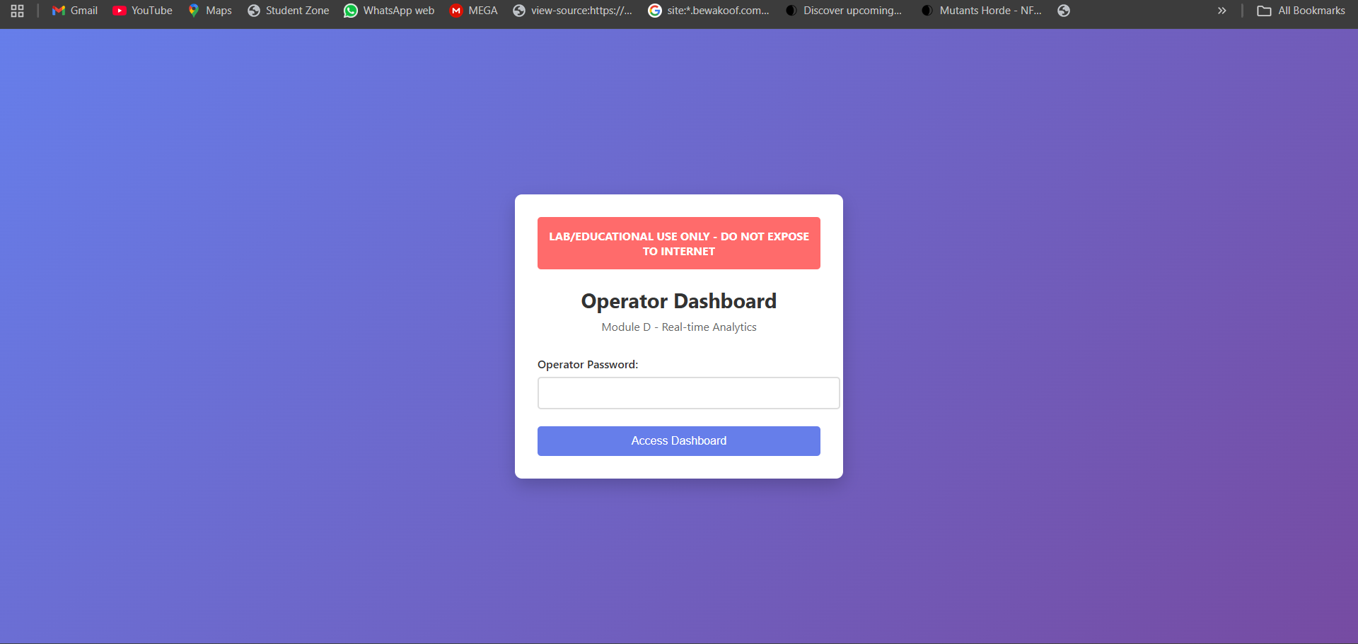
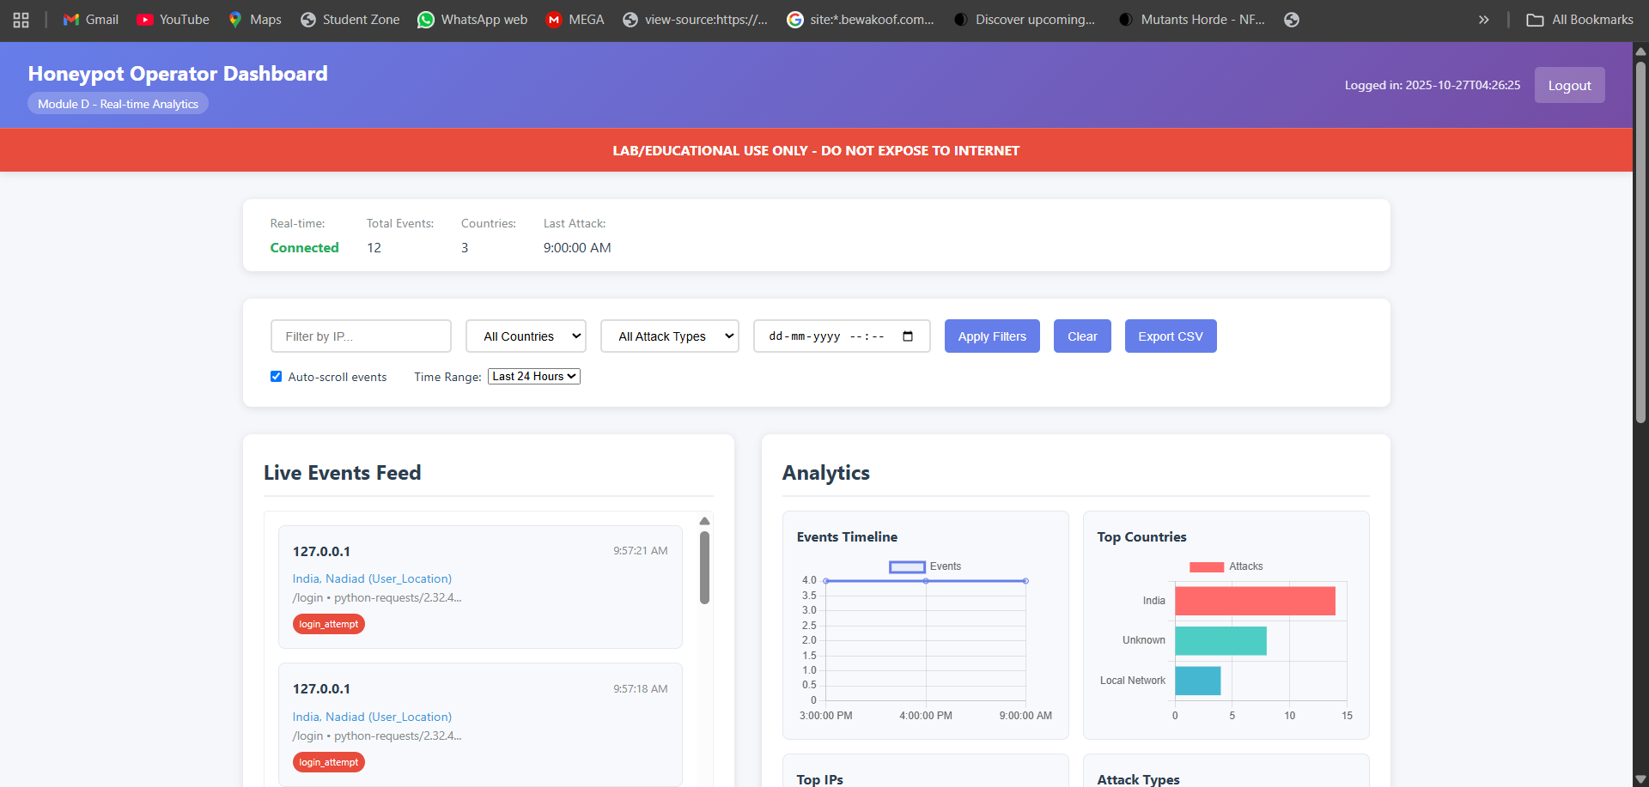
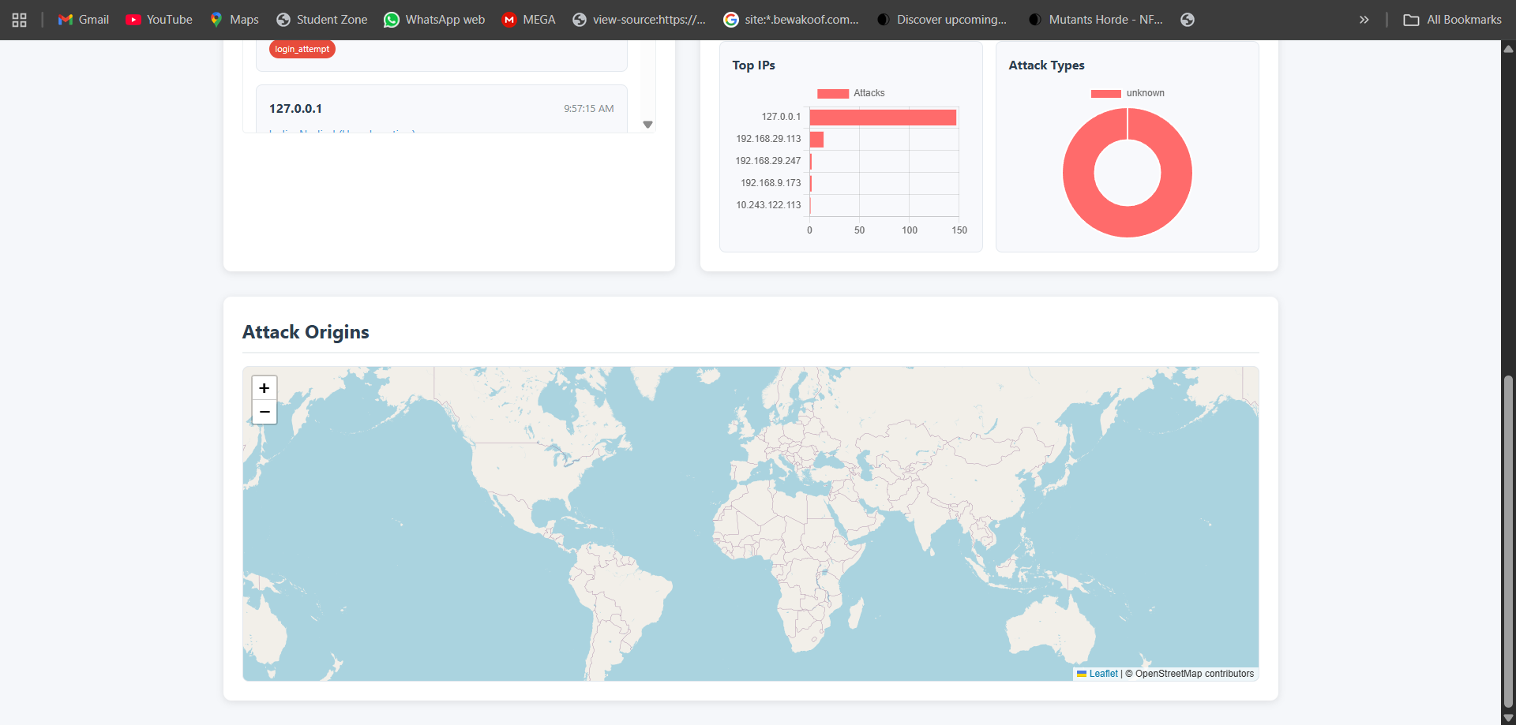
Visualization Dashboard (main)

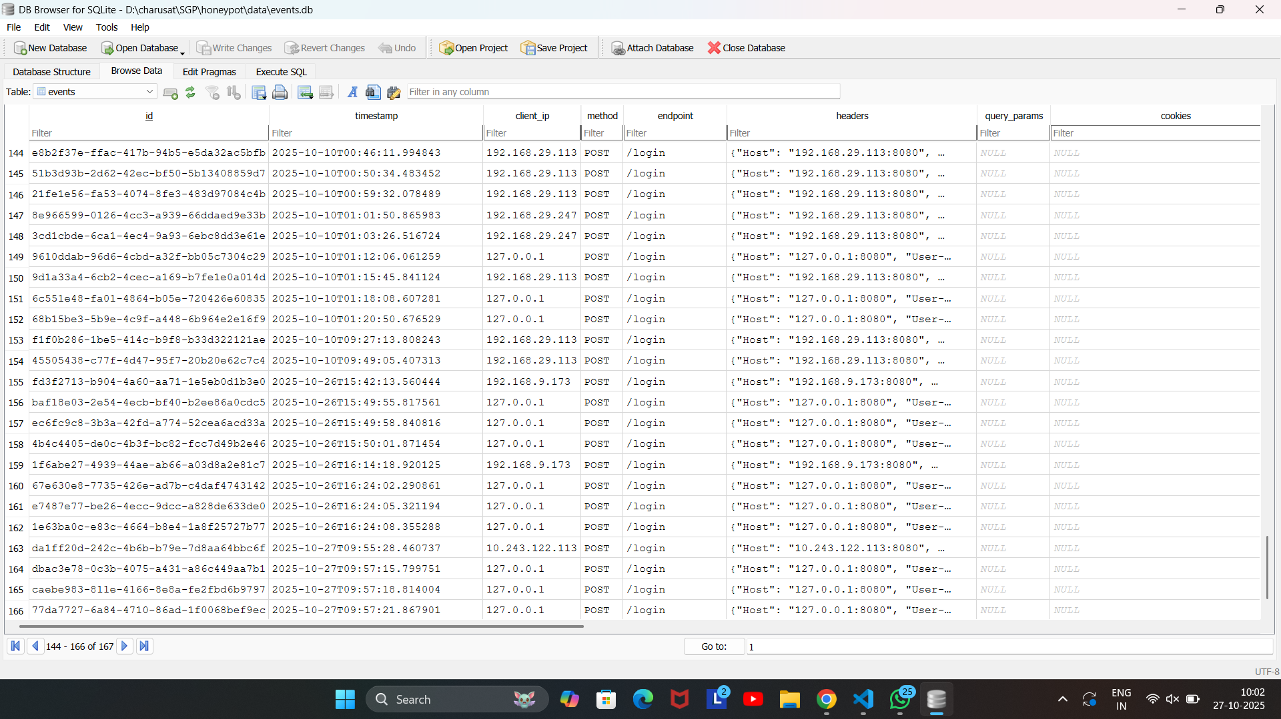
Logs stored in database

Challenges Faced
Development Challenges and Solutions Analysis
1. Geolocation Integration Challenges
- API Reliability Issues: Integration with external geolocation services (ipgeolocation.io, ip-api.com, ipapi.co) faced intermittent failures and rate limiting
- Localhost Testing Limitations: Development environment using localhost (127.0.0.1) IP addresses couldn't provide meaningful geographic data
- Multiple API Fallback Complexity: Implementing a robust cascading fallback system across multiple geolocation providers
Solutions:
- Manual Override System: Implemented configurable location override for development testing
- Public IP Resolution: Automatic detection and resolution of real public IP for localhost testing
- Graceful Degradation: System continues operation even when all geolocation services fail
2. Real-time Communication Architecture
Challenge:
- WebSocket Connection Management: Maintaining persistent connections between honeypot, dashboard, and multiple clients
- Event Broadcasting Reliability: Ensuring real-time event distribution without blocking the main honeypot operation
- Cross-module Communication: Coordinating between standalone honeypot and operator dashboard components
Solutions:
- Flask-SocketIO Integration: Implemented WebSocket communication layer with automatic fallback to long-polling
- Namespace Isolation: Used dedicated /events namespace for real-time communications
- Error Isolation: Real-time failures don't impact core honeypot functionality
3. Frontend Real-time Visualization
Challenge:
- Chart Performance: Updating multiple charts simultaneously without UI lag
- Memory Management: Preventing memory leaks in long-running dashboard sessions
- Event Queue Management: Handling high-frequency event streams efficiently
Solutions:
- Event Batching: Implemented queuing system to batch UI updates
- Chart.js Integration: Efficient chart updates with data point limits
- Leaflet Map Clustering: Marker clustering for geographic visualization performance
4. Authentication and Session Security
Challenge:
- Secure Operator Access: Implementing robust authentication for the operator dashboard
- Session Management: Preventing unauthorized access while maintaining usability
- Route Protection: Selective authentication enforcement across different endpoints
Solutions:
- Middleware-based Protection: Global authentication middleware with route exclusions
- Secure Session Configuration: HTTP-only cookies with configurable security settings
- API Authentication: Separate authentication flow for API endpoints

Future Work

Summary of Project Achievements
The IntruViz: Honeypot with Visualization Dashboard for Intrusion Analysis project successfully achieved its core objectives of creating a functional, beginner-friendly honeypot system capable of detecting and analyzing unauthorized access attempts within a controlled network environment. The team developed the system entirely from scratch using Python, Flask, and Chart.js, ensuring a balance between educational simplicity and technical depth.
The honeypot effectively simulated vulnerable network services, captured critical information such as attacker IP addresses, ports accessed, and timestamps, and visualized this data through an interactive web dashboard. The integration of GeoIP lookups provided additional insight into the geographical origins of attacks. This project also demonstrated strong modularity, with clear separation between data collection, backend processing, and visualization components, making it easier to extend in the future.

Potential Areas for Improvement and Future Features
While the current implementation meets its educational and analytical goals, there is considerable scope for enhancement. Future versions of IntruViz could incorporate the following improvements:
- Advanced Intrusion Detection: Integrate machine learning models to classify and predict attack types based on observed traffic patterns.
- Real-Time Alerting System: Implement automated alerts through email, SMS, or Telegram when suspicious activity or repeated intrusion attempts are detected.
- Expanded Visualization and Analytics: Introduce advanced visualization tools such as Grafana or D3.js for deeper data analysis and more interactive dashboards.
- Multi-Layer Honeypot Deployment: Extend the system to simulate multiple layers or services (e.g., FTP, MySQL, HTTP) for a broader attack surface and more detailed behavioural data.
- Cloud Integration and Remote Access: Deploy the honeypot on cloud environments with secured APIs for remote monitoring and analysis.
- Threat Intelligence Sharing: Enable the system to export collected data to community-driven threat intelligence platforms, contributing to wider research on attack patterns.
- Enhanced Security and Isolation: Improve sandboxing and network segmentation mechanisms to make the honeypot safer for testing real-world attacks in a controlled setting.

Conclusion
The IntruViz project successfully demonstrates how a lightweight, custom-built honeypot can be used to understand and visualize intrusion activities in a controlled environment. Through the integration of Python, Flask, and Chart.js, the system not only detects and logs unauthorized access attempts but also presents this information in an intuitive and interactive dashboard. This makes it easier for students and researchers to comprehend attack patterns, network behavior, and the importance of proactive cybersecurity measures.
The project’s modular design and real-time visualization capabilities highlight its educational value, bridging the gap between theoretical knowledge and practical implementation. By simulating realistic attack scenarios safely within a local network, IntruViz provides a hands-on approach to learning cybersecurity fundamentals.
Overall, this project lays the foundation for future research and development in intrusion detection and visualization. With enhancements such as machine learning–based analytics, automated alert systems, and integration with cloud or threat-intelligence platforms, IntruViz has the potential to evolve into a comprehensive cybersecurity education and monitoring tool.

References
- Singh, R. K., & Ramajujam, T. (2009). Intrusion Detection System Using Advanced Honeypots — arXiv

- Zielinski, D., & Kholidy, H. A. (2022). An Analysis of Honeypots and their Impact as a Cyber Deception Tactic. arXiv

- Lee, J., Jeon, J., Lee, C., & Cho, J. (2016). An Implementation of Log Visualization System Combined SCADA Honeypot. icact.org

- “Using Honeypots for Network Intrusion Detection.” (2020). U.S. HHS Report. HHS.gov

- Djo Njoera, Y. A., Hartawan, I. N. B., Ariana, A. G. B., & Krisna, E. D. (2024). The Analysis Of Honeypot Performance Using Grafana Loki And ELK Stack Visualization. Sean Institute E-Journal

- Kubba, A., Nasir, Q., Elmutasim, O., & Abu Talib, M. (2025). A Systematic Review of Honeypot Data Collection, Threat Intelligence Platforms, and AI/ML Techniques. SSRN. SSRN

